Gwiyoung Lee, Jinpyo Lee, Yeseul Hwang, Jiyoung Choi, Youngsung Kim, Jungeun Yun

Final Report

Ⅰ. Introduction/ background of project and research questions
Popular culture in Koreaㅡmaybe also in the United Statesㅡ is obsessed with physical appearance. We are told the “beauty is only skin deep,” but the entertainment, cosmetic, fashion, and diet industries are eager to convince young people that “looks are everything.” Perfect men are handsome, muscular, and successful. Perfect women are beautiful and thinㅡextremely thin. In fact, women’s thinness is equated with beauty, fitness, success, and ultimately with happiness. Out of curiosity, we want to find out what relationships there are between BMI and gender or BMI and income per year.
BMI (Body Mass Index) is calculated by weight (kg) and height (meter).
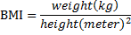
People having BMI between 20~25 are considered as normal while people of BMI under 17 are considered as underweight. BMI is authorized and commonly used throughout the world. Since there is no criterion agreed about over-obesity in Korea, BMI over 35kg/m^2 is selected for the analysis.
The dataset we are going to analyze is ‘BMI rate and its correlation with gender and income level’ research conducted by National Health Insurance Corporation and National Statistical Office of Korea. In order to do our analysis we used datasets of year from 2002 to 2013. Each year’s income level is divided into twenty levels. In total we utilized 240 observations.
First, we want to find out the correlation between BMI rate and ‘gender’. We analyzed our datasets according to gender to find out how BMI rate changed as time goes by from 2002 to 2013. Second, we assume that BMI rate as a high correlation with income level. In order to study correlation between BMI rate and income level, we divided income level in 20 and observed the change of BMI rate in year 2011, 2012 and 2013

Research Questions
Q1. From 2002 to 2013, did the percentage of over-obesity (BMI≥35kg/m²) increase in past eleven years?
Q2. Did the percentage of over-obesity of people in different income level increase?
Q3. Is there any gender difference between the percentage of over-obesity (BMI ≥ 35kg/m2)?
Plan of Analysis
To find out what we are looking for, we chose several statistical methods for the data. So far, we derived the mean, standard deviation, and median of our 240 observations. Also, we drew a scatter plot of BMI rate, x-axis as income, y-axis as BMI rate, and many other colors representing each year. From the scatter plot, we found out that BMI rate and income level shows a negative correlation. Also, the BMI rate of 2013 is slightly higher than followed years. We would further focus on the two points that we derived from our scatter plot and verify these points.

Ⅱ. Methods & results
We used data from 2002 to 2013 from NHIS (National Health Insurance Service). It shows percentage of over-obesity by income level and gender.
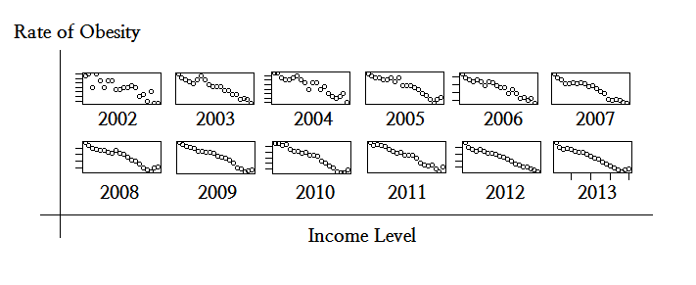
From the plot, we can identify negative correlation between the income level and percentage of over-obesity. To verify the correct numerical value, the correlation was calculated and the result was the negative correlation with coefficient near -1.
Year | 2002 | 2003 | 2004 | 2005 | 2006 | 2007 | 2008 | 2009 | 2010 | 2011 | 2012 | 2013
Corr | -0.87 | -0.95 | -0.93 | -0.95 | -0.96 | -0.96 | -0.96 | -0.98 | -0.98 | -0.98 | -0.98 | -0.98

Year | 2002 | 2003 | 2004 | 2005 | 2006 | 2007 | 2008 | 2009 | 2010 | 2011 | 2012 | 2013
VIF | 10.9 | 57.7 | 28.1 | 72.4 | 49.3 | 100.8 | 379.6 | 186.0 | 150.3 | 177.2 | 113.9 | 207.4
We did regression analysis to test data. Through summary, no variable was significant yet, R-squared values and p-value were high enough to doubt the multicollinearity. As a result, the values were over 10.

In order to do test of independence, constant variance, and normality, we used dwtest, bptest, shpirotest. Results from the test does not satisfy independence but do satisfy constant variance and normality
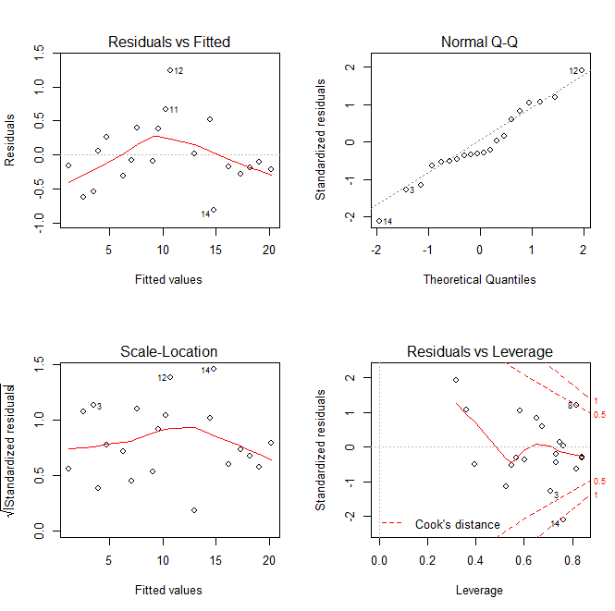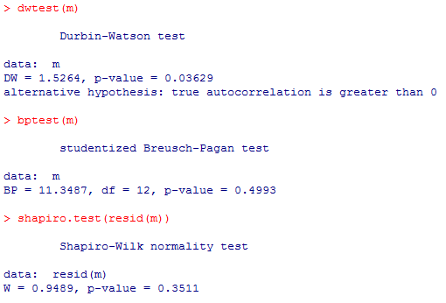
To satisfy statistical independence, we executed transformation of variables, logs and exponents which made changes on data, but it did not work. Finally, we used selection of variables to pick up the most significant variable. Year 2002, 2008, 2009, 2010, 2012 showed out to be comparatively statistically significant. Except the independence, constant variance and normality was satisfied. However, multicollinearity did not still match up with the results of the test. So we had a social-scientific approach on it because it made more sense to us. And we thought about why it was so.

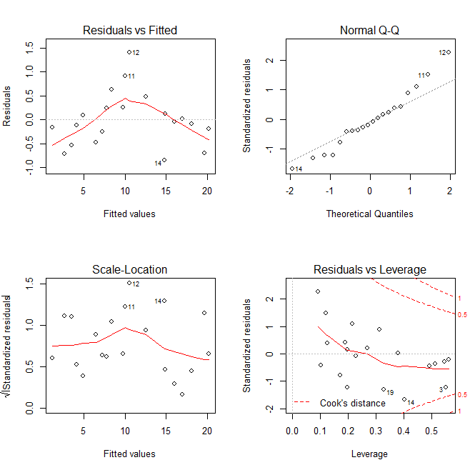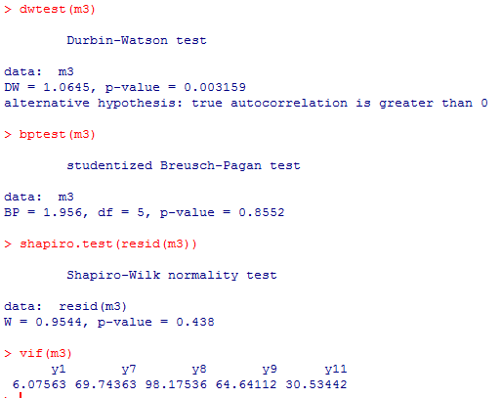

Ⅲ. Discussion
Q1. From 2002 to 2013, did the percentage of over-obesity (BMI≥35kg/m²) increase in past eleven years?
→ The rate of over obesity (BMI≥35kg/m²) reached 0.49% which is about three (2.9) times higher than that of past eleven years.
Q2. Did the percentage of over-obesity of people in different income level increase?
→ The gap between the rate of obesity (BMI ≥ 35kg/m2) of the lowest insurance premium and the highest increased from 0.12% (2002) to 0.40% (2013)
Q3. Is there any gender difference between the percentage of over-obesity (BMI ≥ 35kg/m2)?
→ In the lowest insurance premium, gender difference between the percentage of over-obesity (BMI ≥ 35kg/m2) is increased from 0.02% in 2002 to 0.16% in 2013.

The research shows that the percentage of over-obesity and obesity is increasing in the classes looking for convenience. According to one hundred million generic health examination data from 2003 to 2013 analyzed by the Health Insurance Corporation, the percentage of over-obesity increased from 0.2% to 0.5%, and that of obesity increased 2.5% to 4.2% during this period. The over-obesity rate increased from 0.2% to 0.5% in 12 years which is 2.9 times higher than 2002. Especially, women of 30s (3 times), women of 20s (2.8 times), men of 30s (2.3 times), men of 20s (2.2 times) ranked the largest increase in order.
1. Cheap and convenient fast food is available nowadays and as a result, people having active social life have more chance to be exposed to it than the elderly.
2. Due to the development of technology, transportation became easy. Increase in supply of elevator in buildings and cars could have influenced human activity.
3. Weak will to control one's weight will result in obesity
Several years ago, a Korean newspaper treated an article that related BMI rate and wealth. It said that ‘fat’ gives the image of poor, unhealthy, and lazy while ‘slim’ gives a pleasant image. In Korean there are many mediums that help one lose weight such as a health club, beauty salon treatment, and plastic surgery. Yet, all of these mediums require money. Also, cheap fast food is high in calories while expensive healthy food is rather expensive. It seems as if it is much easier for the wealth to lose weight than the poor.
The reason why the statistical investigation does not show any significance is that the rate of obesity of male subjects with top 5% income level has rised. Furthermore, the graph is too fluctuating to be statistically significant

Ⅳ. Conclusion and future directions
The relevance between BMI index and income is not statistically significant, but the BMI of people with high income is comparably higher than who do not generate such income. This sheds light on drawing up concrete regulations in social welfare and public health policy. For instance, local governments or cities operate gyms free of charge-or at an affordable price- maintained by public welfare enterprises. This can offer lower-income group a chance of getting various kinds of exercise like yoga or personal training. Also, by holding seminars on the necessity of a balanced diet or on making a simple balanced diet, the low-income bracket will get some support on their health care. In another point of view, social perceptions had a strong bond with the fact that women had lower BMI index than men. Social perception on “ideal body” needs to change from being thin to being fit and healthy. This conversion will stop women from trying to be so thin. Moreover, this switch in cognition will work better if those kind of women is cast as models in magazines and if firms subsidy in holding these campaigns. Men having a higher BMI index cannot be separated from the Korean company dinner culture. If office workers have dinner in a different way, it will reduce the gap between BMI indexes of opposite gender.
References
National Health Insurance Service http://www.nhis.or.kr/bbs7/boards/B0039/12767

